**Lastname, Firstname**

**CS214 – Database Technologies**

**HOP NUMBER**

**Part 1**

**SCREENSHOT #1**

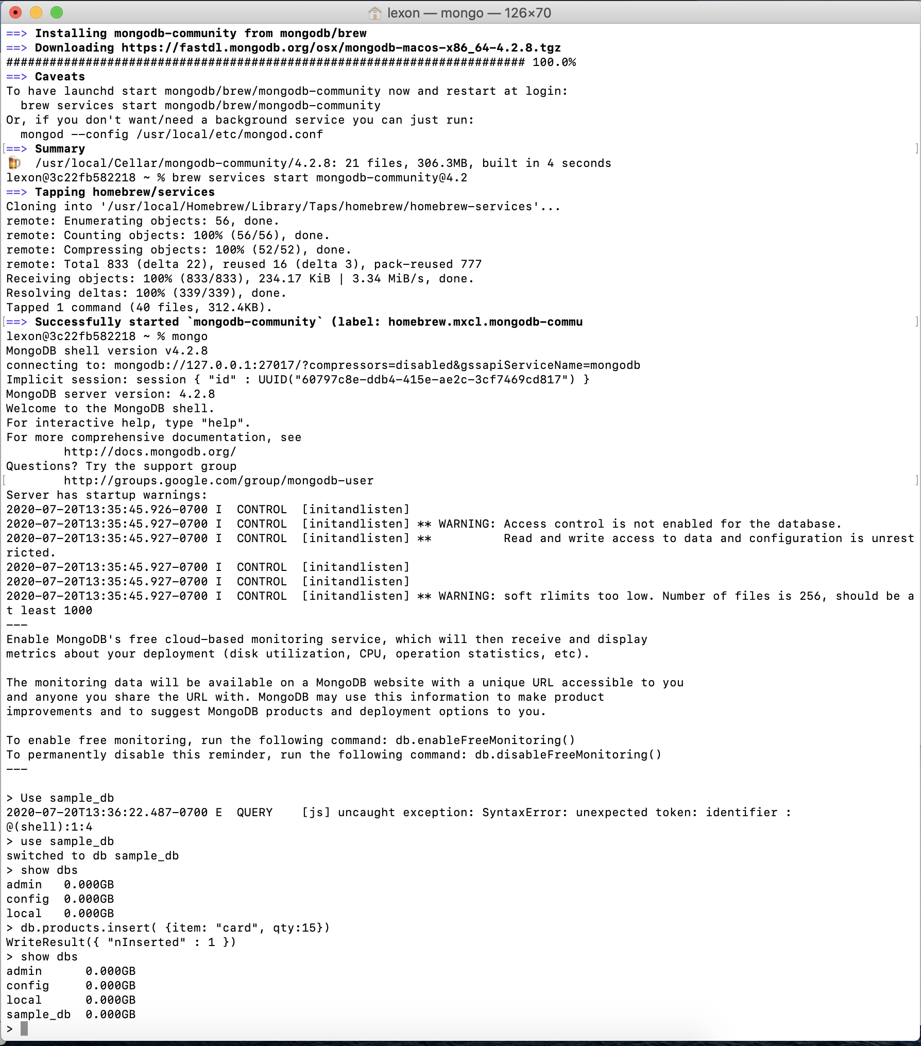

**PART 2**

This HOP consisted of step by step instructions on how to install mongobd and homebrew as well as integrating them with each other which I was able to accomplish successfully.